**CHAPTER SEVEN**

**SET – PRT TWO**

**THREE SET PROBLEM**

Note the following:

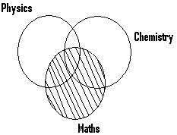

The shaded portion represents those who study maths.

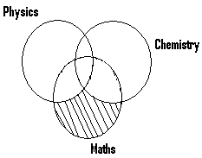

The shaded portion represents those who study only maths.

(3)

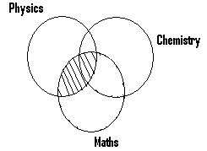

Shaded portion represents those who study physics and maths.

(4)

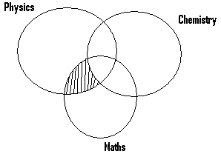

The shaded portion represents those who study only physics and math (or physics and maths only).

(5)

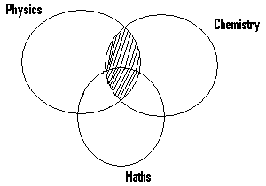

The shaded portion represents those who study physics and chemistry.

(6)

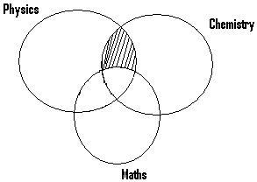

The shaded portion represents those who study physics and chemistry only i.e only physics and Chemistry.

(7)

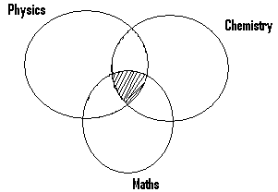

The shaded portion represents those who study physics, chemistry and maths (ie those who study all the three subjects).

(8)

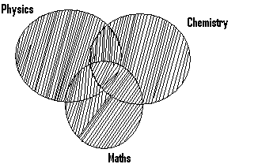

The shaded portion represents those who study physics or chemistry or maths.

(9)

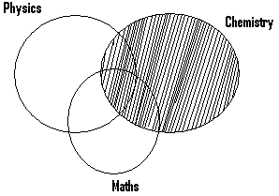

The shaded portion represents those who study chemistry.

(10)

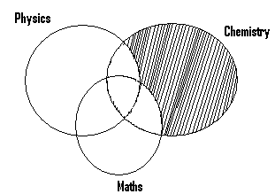

The shaded portion represents those study chemistry only or only chemistry.

Examples

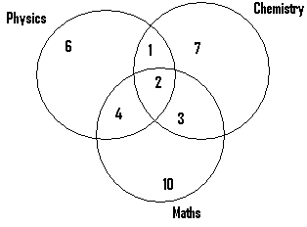

1. n(those whose study physics)

= 6 + 4 + 2 + 1 = 13.

1. n(those whose study only physics) = 6.
2. n(those who study only physics and chemistry) = 1.
3. n(those who study physics and chemistry

= 1 + 2 = 3.

1. n(those who study maths and physics)

= 4 + 2 = 6.

1. n(those who study maths and physics only) = 4.
2. n(those who study all the three subjects) = 2.
3. n(those who study study only chemistry) = 7.
4. n(those who study chemistry).

= 1 + 2 + 3 + 7 = 13.

1. n( those who study only one subject

= 6 + 7 + 10 = 23.

1. n(those who study only two subjects

= 1 + 3 + 4 = 8.

1. n(those who study three subjects) = 2.
2. n(those who study physics or chemistry or maths = 6 + 1 + 2 + 4 + 10 + 3 + 7 = 33.

Q1. In a sixth form, 12 students study maths, 16 study chemistry and 21 study physics.

Only three study all the three subjects. Five students study maths and chemistry. Eight study maths and physics and twelve study physics and chemistry.

Find the number of those who study.

1. Chemistry only.
2. Chemistry and maths only.
3. Physics only.
4. Physics and maths.
5. Physics and maths only.
6. Physics and chemistry only.
7. Physics only.

N/B: for better understanding, the steps to be used in solving questions, will be increased, but in solving questions, you must use only a few steps as possible.

Soln.

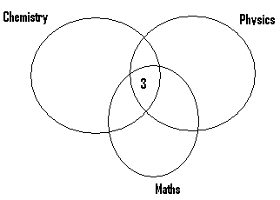

The 3 people who study all the three subjects must be represented as indicated.

* Also we are told that 5 students study maths and chemistry.

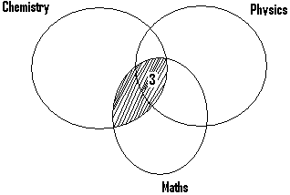

* This implies that the number of those to be found within the shaded portion must be 5.
* Since 3 out of this 5 has been indicated in one part of the shaded portion, then the remaining 2 must occupy the other portion as shown next.

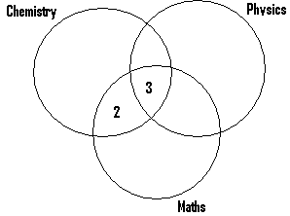

Also we are told that 8 study student maths and physics.

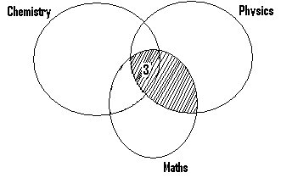

This implies that the total number of those who should be within the shaded portion must be 8. Since 3 out of this occupy one portion, then the remaining 5 must occupy the other portion as indicated in the next diagram.

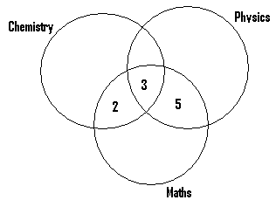

Also 12 students study chemistry and physics.

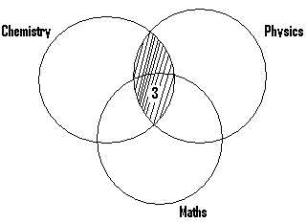

* This implies that those to be found within the shaded portion must be 12.
* The other portion of the shaded part must therefore contain 9 students.

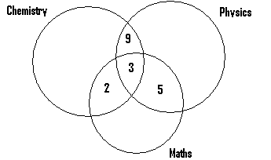

Now let k = the number of those who study only chemistry.

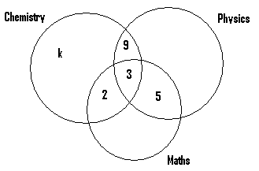

Since 16 study chemistry, them the number of those within the shaded portion must be 16

$$⟹k+9+3+2=16⟹k+14=16⟹k=16-14⟹k=2$$

Let x = the number of those who study physics only

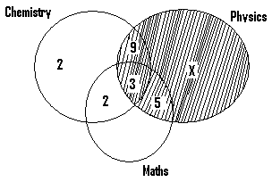

Since 21 students study physics, then the number of those within the shaded portion must be 21

$$⟹x+9+3+5=21⟹x+17=21⟹x=21-17⟹x=4$$

Lastly let m represent the number of those who offer only maths.

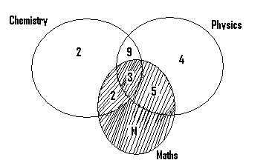

Since 12 study maths, then the number of those within the shaded portion must be 12

$$⟹m+ \\ 2+3+5=12⟹m+10=12⟹m=2$$

Our final venn diagram becomes as shown next.

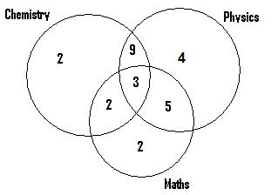

1. n(those who study chemistry only) = 2
2. n(those who study chemistry and maths only)

= 2

1. n(those who study physics only) = 4
2. n(those who study maths and physics

= 3 + 5 = 8

1. n(those who study maths and physics only) = 5
2. n(those who study physics and chemistry only) = 9
3. n(those who study only physics) = 4.

Q2. Out of the 35 students in a class, 27 study Emglish, 23 study Art and 19 study History. 18 students study English and Art, 15 study English and History and 13 study Art and History. Given that 10 students study all the three subjects, find the number of those who study

1. Only English
2. Art and English only
3. English and History only
4. None of these three subjects.

Soln.

n(students in class) = 35

n(those who study English) = 27

n(those who study Art) = 23

n(those who study History) = 19

n(those who study English and Art) = 18

n(those who study English and History) = 15

n(those who study Art and History) = 13

n(those who study all the three subjects = 10

From this given data, the following facts can be deduced.

1. n(those who study English and Art only)

= 18 – 10 = 8

1. n(those who study English and History only)

= 15 – 10 = 5

1. n(those who study Art and History only)

= 13 – 10 = 3

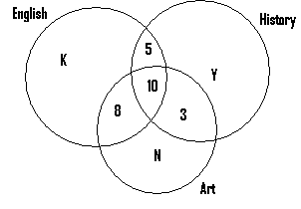

* Let k = the number of those offering only English, N = the number of those offering Art only, and y = the number of those offering only History.
* Since 23 study Art $⟹8+10+3+N=23⟹21+N=23⟹N=23-21$
$$⟹N=2$$

* Also since 19 study History $⟹y+5+10+3=19⟹y+18=19⟹y=19-18⟹y=1$
* Lastly since 27 study English $⟹k+8+10+5=27⟹k+23=27⟹k=27-23⟹k=4.$

Our venn diagram becomes as shown next:

English

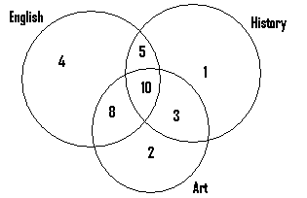

1. n(those who study English only) = 4
2. n(those who study Art and English only) = 8
3. n(those who study English and History only)

= 5

1. n(those who study history or English or Art)

= 4 + 5 + 10 + 8 + 2 + 3 + 1 = 33

n(students in the class) = 35

$⟹$ n(students who study none of the three subjects) = 35 -33 = 2.

Q3. In a survey on sports, the following data was obtained.

Number of football fans = 18

Number of boxing fans = 22

Number of martial art fans = 17

Number of football and boxing fans = 9

Number of martial Art and boxing fans = 14

Number of football and martial Art fans = 6

Number of only boxing fans = 3

Number of only football fans = 7.

Find the number of those who like

1. all the three types of sports
2. football and boxing
3. football only
4. football and martial art only

N/B: This type of question differs from those previous ones solved.

* In the previous ones solved, the number of those who take part in all the three types of events is given, but this is not so in this case.
* For this reason the solution to this type of question is shown next.

Soln.

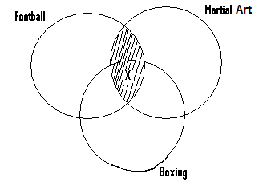

Let x = the number of those who like all the three types of sporting events.

* Since 6 people like football and martial art, then the number of those within the shaded portion must be 6
* Since x out of this number can be found in one part of the shaded portion, then the number of those who must occupy the other part = 6 – x

i.e

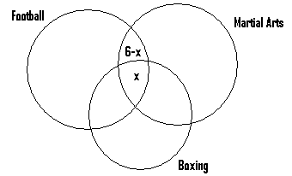

Also since 9 people like football and boxing

$⟹$ the number of those who like football and boxing only = 9 – x

* Lastly since 14 people are fans of martial art and boxing, $⟹$ the number of those who are fans of martial art and boxing only=14–x

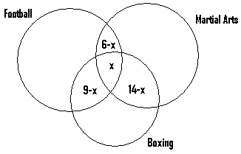

Given also that 7 people like only football and 3 like only boxing, then the last diagram will look as shown next.

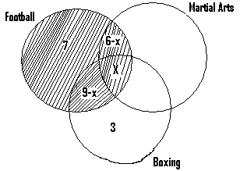

Since 18 people are fans of football $⟹$ the number of those within the shaded portion = 18

$$⟹7+6-x+x+9-x=18⟹22-x=18⟹22-18=x⟹x=4$$

Replacing x with 4, our venn diagram becomes as shown next.

Football

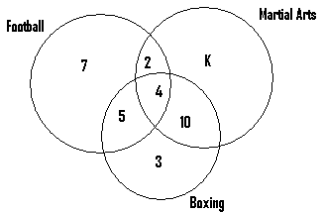

Let k= the number of those who are fan of Martial Art only. Then since 17 like martial art, K + 2 + 4 + 10 = 17, $16+k=17 k=1.$

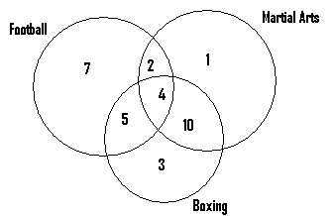

1. n(those who like all the three types of sporting events) = 4.
2. n(those who like football and boxing) = 5 + 4 = 9.
3. n(those who like football only) = 7.
4. n(those who like football and martial art only) = 2.

Q4. In a class of 32 students, 18 offer chemistry, 16 offer physics and 22 offer maths. 6 offer all the three subjects, 3 offer chemistry and physics only, 5 offer physics only, 8 offer maths and physics. Each student offers at least one of these subjects. Find the number of students who offer

1. Chemistry only
2. Only one subject
3. Only two subjects

Soln.

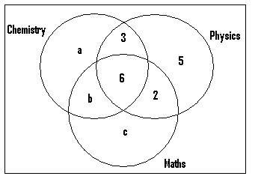

Let a = the number of those who offer only chemistry, b = the number of those who offer chemistry and maths only, and c = the number of those who offer only maths. Since 18 offer chemistry $⟹a+b+3+6=18⟹a+b+9=18⟹a+b=18-9a+b=9…eqn\left(1\right)$

Also since 22 offer maths $⟹b+c+6+2=22⟹b+c+8=22⟹b+c=22-8⟹b+c=14…………eqn(2)$

Lastly since the total number of those who offer all the 3 subjects altogether = 32, then a+b+c+2+6+3+5 = 32

$$⟹a+b+c+16=32$$

$$⟹a+b+c=32-16$$

$$⟹a+b+c=16…………eqn(3)$$

From eqn. (2), b + c = 14

Substitute this in eqn. (3)

$⟹a+b+c=16⟹a+14=16⟹a=16-14=2a=2$.

$$from eqn \left(1\right),a+b=9⟹2+b=9⟹b=9-2⟹b=7$$

From eqn. (2), b + c = 14 $⟹7+c=14$

$⟹c=14-7⟹c=7$.

Our venn diagram becomes as shown next.

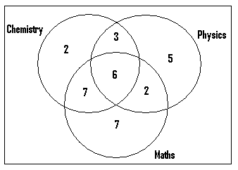

1. n(those who offer chemistry only) = 2
2. n(those who offer only one subject)

= 5 + 7 + 2 = 14

1. n(those who offer only 2 subjects)

= 3 + 7 + 2 = 12

N/B: Since there are 32 students in the class, and each of them study at least one of the three subjects, them the total number of those who offer the three subjects altogether (ie physics or chemistry or maths) = 32.

Q5. Some students were interviewed to find which of the following three sports they like: football, boxing and volleyball. 70% of them liked football, 60% boxing and 45% volley ball. 45% liked football and boxing, 15% boxing and volleyball, 25% football and volleyball and 5% liked all the three types of sports.

1. Draw a venn diagram to illustrate this information
2. Use your diagram to find the percentage of students who like
3. football but not volleyball.
4. exactly two sports.

N/B: Since we are dealing in percentages, then the total number of students interviewed =100

Soln.

1. n(those who like football) = 70% of 100 $=\frac{70}{100}×100=70students$

n(those who like boxing) = 60% of 100

$=\frac{60}{100}×100=60 Students$.

n(those who like volleyball) = 45% of 100

$=\frac{45}{100}×100=45 Students$.

n(those who like both football and boxing) = 45% of 100 $=\frac{45}{100}×100=45 Students$

n(those who like boxing and volleyball) = 15% of 100

$=\frac{15}{100}×100=15 Students$.

n(those who like football and volleyball)

= 25% of 100 $=\frac{25}{100}×100=25 students$

n(those who like all the three sports) = 5% of 100

$$=\frac{5}{100}×100=5 students$$

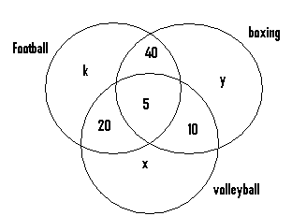

x volleyball

Let k = the number of those who like only football. Since 70 students like football

$$⟹k+20+5+40=70⟹k+65=70⟹k=70-65=5⟹k=5$$

Let x = the number of those who like only volleyball.

Since 45 students like volleyball

$x+20+5+10=45⟹x+35=45⟹x=45-35⟹x=10$.

Lastly let y = the number of those who like only boxing. Since 60 students like boxing

$$⟹y+10+40+5=60⟹y+55=60$$

$$⟹y=60-55⟹y=5$$

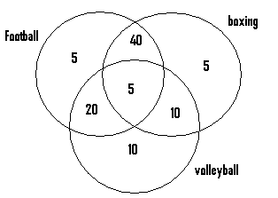

1. n(those who like football but not volleyball) = 40 + 5 = 45.
2. n(those who like exactly two sports)

= 40 + 20 + 10 = 70.

N/B:

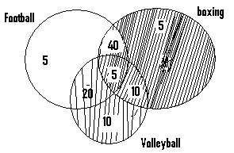

For n(those who like football but not volleyball, we do not consider those within the unshaded portion.

**Questions:**

1. In a certain science class, 11 students study physics, 21 study chemistry and 19 study maths. 3 study all the three subjects, 8 study physics and chemistry, 4 study maths and physics and 10 study chemistry and maths.
2. Represent this on a venn diagram

Ans:

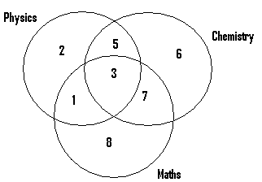

(b) Determine the number of those who study

1. only physics Ans: 2
2. only chemistry Ans: 6
3. physics or chemistry or maths Ans: 32

Q2. Out of the 50 students who went to a school food festival, 18 did not take in rice or beans or cassava. Of those who took in these food items, 12 took in rice, 13 took in beans and 21 took in cassava. 2 students took in all the three types of food items, 1 took in beans and rice only, 7 took in cassava and rice and 4 took in beans and cassava only.

1. Draw a venn diagram to illustrate this given information.

Ans:

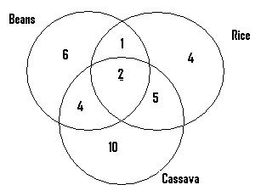

(b) Determine the number of those who took in

1. only cassava. Ans: 10
2. only one type of food item. Ans 20
3. rice but not beans. Ans: 9

Q3. The languages spoken by the students of a certain university are English, Spanish or French; 6 speak English and Spanish,

8 speak Spanish and French, 5 speak English and French, 2 speak only French and 3 speak only Spanish. If there are 5 people who speak only English, and 13 speak English,

1. represent this on a venn diagram

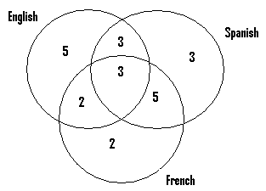

1. determine the number of those who speak
2. French and English only Ans: 2
3. Spanish Ans: 14
4. All the three subjects Ans: 3
5. Only two subjects Ans: 10
6. Only one subject Ans: 10

Q4. A group of workers at a company were classified as blacks, white, Asians or a combination of these races. 9 workers were classified as black and white, 1 Asian and white only, 7 black and Asian, and 2 black only. There were also 8 workers who were classified as only Asians and 5 were considered as white only. If the number of black workers were 13,

1. represent this on a venn diagram

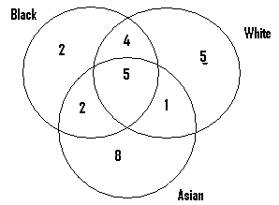

1. Determine the number of worker who were
2. Asians Ans: 16
3. White and Asians Ans: 6
4. White Ans: 15

Q5. One day 38 students had a choice of biscuit, toffee or bread. 8 chose biscuit and toffee, 6 chose biscuit and bread while 10 chose bread and toffee. There were 2 students who chose only biscuit, and 4 chose only bread. If each student chose at least one of these items:

1. Represent this on a venn diagram

Biscuit

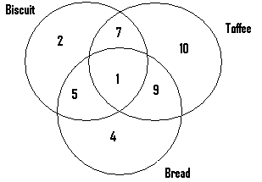

1. Find the number of those who chose
2. bread and toffee only Ans: 9
3. toffee Ans: 27
4. all the three items Ans: 1

Q6. Within a certain community, 28 residents have travelled by a least one of the following transportation means: plane, train or bus. 7 have travelled by both plane and train, 10 by train and bus, 6 by plane and bus, 1 by plane only, 7 by bus only and 5 by train only

1. Represent this on a venn diagram

Ans:

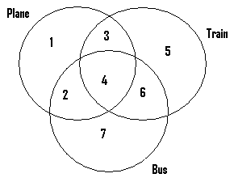

1. Determine the number of those who have travelled by
2. all the three transportation means: Ans: 4
3. bus Ans: 19
4. plane and train Ans: 7

Q7. Out of the 50 people who attended a party, 10 took in wine, 14 took in beer and 8 took in fanta. The next table gives further details:

n(those who took in all the three types of drinks) = 2.

n(those who took in wine only) = 1.

n(those who took in fanta only) = 1.

n(those who took in only beer) = 4.

1. Draw a venn diagram to represent this given information.

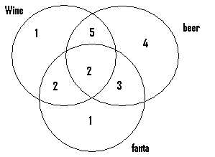

(b)Determine the number of those who took in:

1. Beer and wine Ans: 7
2. Wine and beer only Ans: 5
3. Fanta and wine Ans: 4
4. Fanta and wine only Ans: 2

Q8. During at a birthday party, 10 guests took in wine, 14 took in beer and 8 took in fanta. The following table gives further details:

All three types of drinks ------- 2.

Wine only -------- 1.

Fanta only -------- 1.

Beer only --------- 4.

(a) Represent this on a venn diagram. Ans:

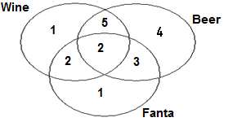

1. Find the number of those who took in
2. beer but not Fanta. Ans: 9.
3. beer and fanta Ans: 5
4. wine and beer Ans: 7
5. fanta and beer only Ans: 3
6. only one type of drink Ans: 6

Q9. Within a sporting club, 10 members play table tennis, 14 play football and 11 play golf. 2 people play only table tennis and football, 5 play only golf and football and 4 play only table tennis and golf. If one person play only golf,

1. Represent the given information on a venn diagram.

Table tennis

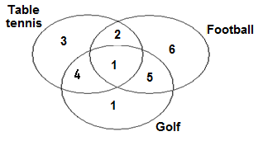

1. Find the number of people who play
2. all the three types of sporting events Ans: 1
3. table tennis or football or golf Ans: 22
4. only one type of game Ans: 10